
Course Name: Design Project-1
Section: 1

Complex Engineering Project Proposal
Project Name: Central Banking System
Submitted by: Group 4
Name | ID
Md Fuad Anan | 251014032
Tapu Shikari | 222014064
Sithi Saha | 242014064
Jannatul Ferdous Lamia | 242014001
Maha Islam | 252014045

Department of Computer Science of Engineering (CSE)
Submitted to:
Md Al Amin Sheikh, PhD
University of Liberal Arts Bangladesh

Title: Central Banking System
Introduction: A central bank is an institution that manages the monetary policy of a country or monetary union. In contrast to a commercial bank, a central bank possesses a monopoly on increasing the monetary base.^{[1]} It makes sure commercial banks follow the rules, controls the money supply and maintains financial stability. The central bank also has to be transparent, watch over banking activities and protect the system from cyber threats and security risks. Many computerized systems are used to manage banking operations, such as processing transactions, managing accounts and reporting. However, a lot of these systems are complicated, hard to monitor and difficult to manage. This makes it difficult to monitor and supervise multiple banking operations simultaneously. In Bangladesh, Bangladesh Bank has started digital initiatives, like electronic fund transfer systems, real-time payment settlement mechanisms and mobile financial services. These changes show how important digital technologies are in banking operations. Automation in banking is necessary because it reduces mistakes, speeds up processing, makes things more transparent and helps with decision-making. That is why developing a Central Banking System Simulator is a valuable initiative. This simulator can give people an idea of banking operations, test processes and train users without affecting the actual banking system. This is especially important for institutions like Bangladesh Bank, where monitoring and managing banking activities efficiently crucial. The Central Banking System Simulator will be very useful for Bangladesh Bank. Bangladesh Bank can use the simulator to understand banking operations. The simulator will help Bangladesh Bank test processes and train its users. This will make Bangladesh Bank more efficient and effective. The Central Banking System Simulator is a tool for Bangladesh Bank and other central banks. It will help them improve their operations and provide services to people.
References (cited in introduction): Central bank. (2026). In Wikipedia. Retrieved June 21, 2026, from https://en.wikipedia.org/wiki/Central_bank^{[1]} (Liang, 2018), (Schildt, 2019), Bangladesh Bank Reports, Online Banking Systems Research Articles, Course Materials.
Problem Statement: Existing Central Banking management systems face obstacles in managing massive amounts of transactions data and ensuring efficient, secure, and financial executions. One major problem is the absence of a centralized monitoring system. When we have to manage commercial banks without one system, it is hard to keep track of what is going on with transactions. Security is also an important issue because financial systems can be easily attacked by cyber threats and unauthorized access. Monitoring transactions is also tough because of the high volume and speed of financial activities. Existing systems often have trouble spotting transactions or unusual activity quickly. Rules from regulators require reports to be strong and controls to be in place. Traditional systems do not always work well with these controls. Current systems may face problems to detect fraudulent transactions. Furthermore, regulatory compliance is an issue. These systems should report accurately and have strict controls. The existing systems may have some problems detecting fake transactions or unusual activities. We also have to follow the rules, which can be hard to do with the existing systems. There are no models available to simulate financial crises. Current systems do not provide a safe environment to test how banks would respond to economic disruptions. There is a simulator is needed to solve these problems. It will provide a controlled platform to monitor, test, and analyse banking operations. This system will show how central banks use it to manage stability. The simulator will help demonstrate its role in maintaining stability and work more efficiently. The target users of this system include students, researchers, and educators who want to understand central banking operations, as well as developers interested in financial system design.
Objectives:
The main objective of our project is to design and develop a Central Banking System Simulator for managing and monitoring banking operations.
Specific mini goals of our project are:
- Make a System where multiple banks are registered and managed under Central banking System.
- Do money supply control operations to keep economy running.
- Monitor banking transactions between commercial banks so things like fraud and money laundering does not happen.
- Manage national reserve’s information so nation does not face financial crises.
- Give a smooth user-friendly graphical interface so user can be comfortable using it
- Generate reports about banks and their risks in investment.

Methodology:
The project will be completed through the following steps:
1.Analysis of Requirements: At first, we will study how a central bank works and it features. We will decide which elements, such as bank registration and removal, customer administration, transaction processing, reserve management, loan handling, and report production, must be implemented in the system based on our findings.
2. System Design: After verifying the requirements, we will design the structure of the system using UML diagrams. The Use Case Diagram will show how users interacts with the system. The classes and their connections will be described in the class diagram. The Activity Diagram will explain the flow of various banking procedures, while the Sequence Diagram will show how different objects communicate with each other during system execution.
3. UML Diagrams: Below are the UML diagrams of this project like use case diagram, Class diagram, Sequence Diagram, Activity Diagram, Component Diagram and Deployment Diagram:
Context Diagram:
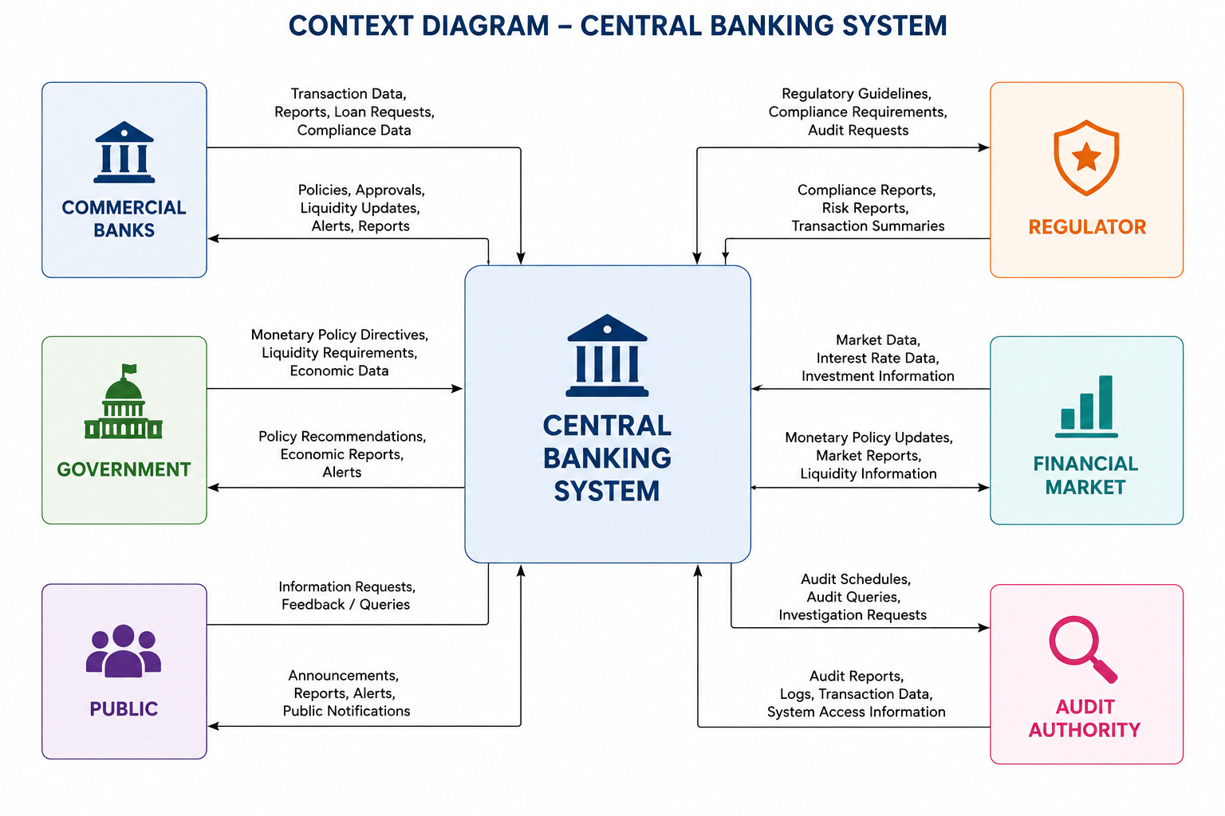
Use-Case Diagram:
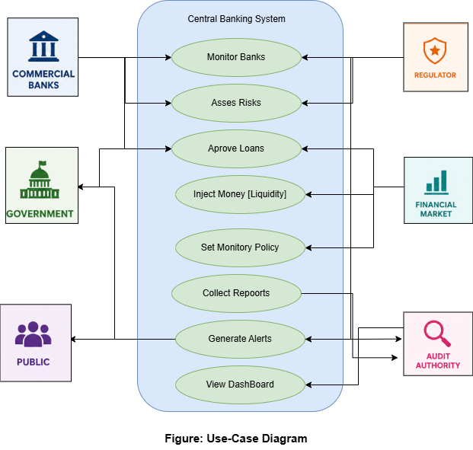

Class Diagram:

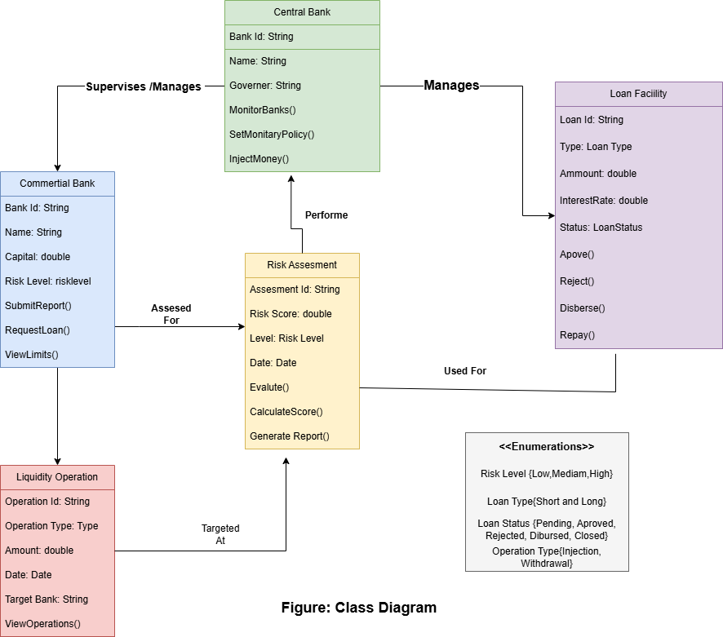

Sequence Diagram:
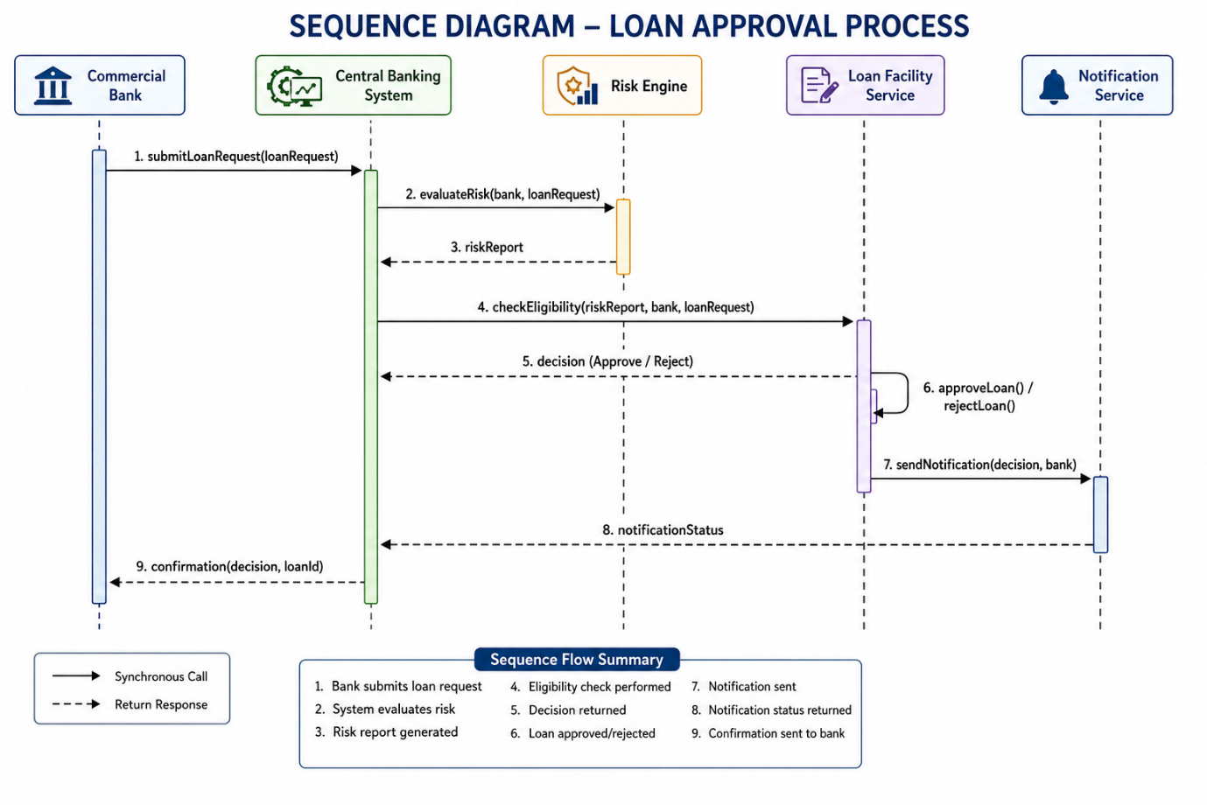

Figure: Sequence Diagram

Activity Diagram:
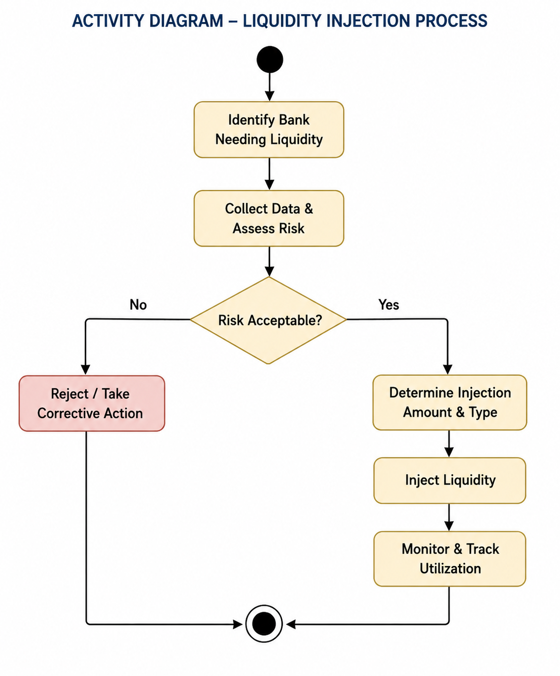Figure: Activity Diagram

Component Diagram:
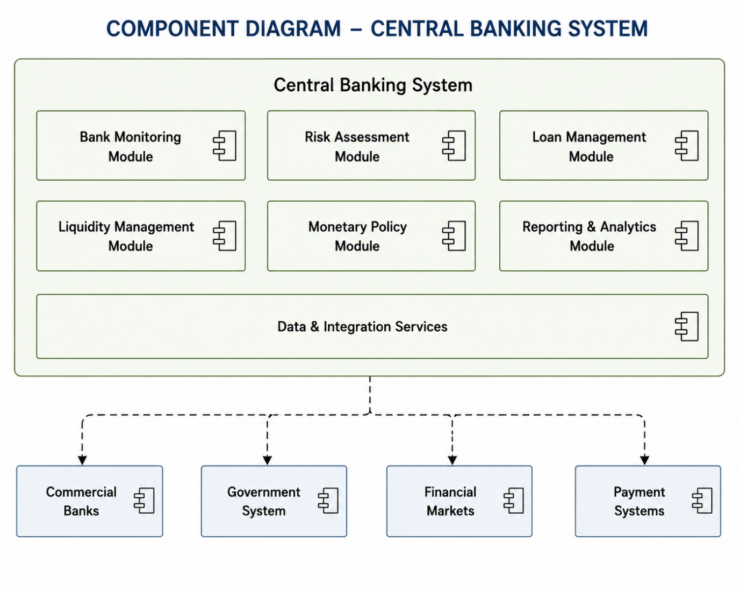Figure: Component Diagram

Deployment Diagram:
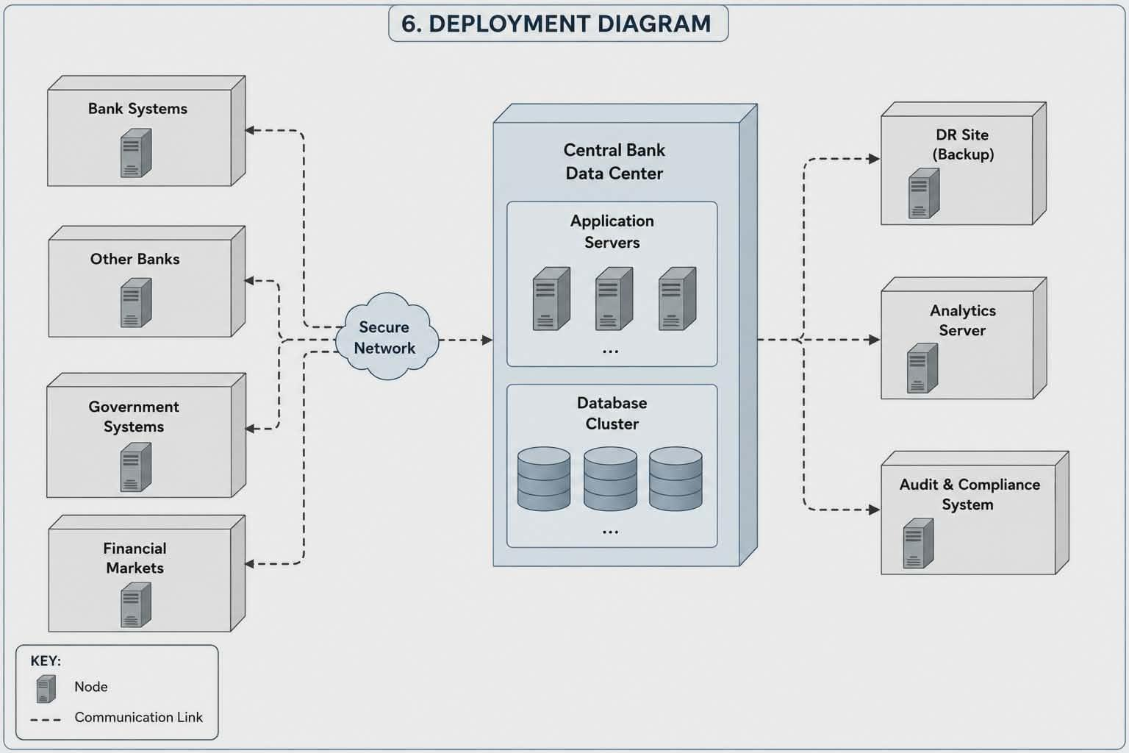
Figure: Deployment Diagram

4.Database Design: A database will be used to store and manage system information. The Bank Table will contain information about commercial banks. The Customer Table will store customer details and account information. The Transaction Table will keep records of all transactions. The Reserve Table will maintain reserve-related information of banks, and the Loan Table will store loan details and repayment status.
5. Technology Stack:
Programming Language: Java
GUI Framework: Java Swing, JavaFX, Java SWT, Java AWT etc. if later needed.
Development Environment: NetBeans IDE, VS code.
6.Implementation: In this phase, we will develop the system using Java and Object-Oriented Programming concepts. Classes such as CentralBank, CommercialBank, Customer, Account, Transaction, Reserve, and Loan will be created to perform different tasks. Database connectivity and file handling will be used where necessary to store and manage data.
7.Testing and Debugging: Once the implementation is completed, we will test the system in different situations to ensure that it works properly. We will check for invalid inputs, transaction errors, and other possible issues. Any bugs found during testing will be fixed before the final version is completed.
8.Evaluation: At last, we will verify the system as a whole to make sure it fulfils the project specifications. To make sure it functions well and achieves the desired goals, we will analyse its accuracy, functionality, and general performance.

Timeline: This is the planned timeline of the project that our group would complete according to course timeline.
Weeks | Activity
Week - 1 | Topic Selection: Selecting the main topic of project.
Week - 2 | Proposal Submit: Submit the project’s proposal document.
Week - 3 | Presentation: Present a presentation to help teacher in understanding the project.
Week - 4 | Requirement analysis: Analyse the requirements to build this project
Week - 5 | System design: Design the overall system architecture, database structure, workflow, and project modules
Week - 6 | UML diagrams: Create UML diagrams that project is required.
Week – 7 | Coding: Code the necessary codes of the software of the project.
Week – 8 | Implementation: Implement the things of System design and UML Designs with coding.
Week – 9 | GUI development: Develop a Graphical User Interface according to system need.
Week – 10 | Integration: Integrate the GUI with the rest of the codes.
Week – 11 | Testing: Test the developed software to check if the software it running smoothly
Week – 12 | Debugging: Debug or fix and errors in the codes of the project software.
Week - 13 | Final report: Submit the final report with the software with codes and related things in docs or pdf file.

Expected Outcomes: By completing this project we are expecting ourselves to develop and design a Functional GUI Central Banking simulator that works like how real-world central bank does banking operations efficiently.
This system also has features like secure transaction management, a monitoring dashboard to monitor banks and give status update like generating reports and statistics. It also gives crisis simulation capability like how central banks respond to economic disruptions to user.
Also, working on this project gives us valuable practical experience like how in real life central bank works. Also, developing this system will give us hand on experience in building software form scratch.
This project building helps us in improving our programming skills (like Object-Oriented Programming), system design and its implementation, problem solving, and teamwork and collaboration skills. Especially in team work because it is our first team software developing. It would enhance our ability in a team environment. This would be useful for our future academic and professional careers.
References:
  - Liang, Y. Daniel. Introduction to Java Programming and Comprehensive Version 10th edition. Pearson.
  - Schildt, Herbert. Java: The Complete Reference, 11th Edition. McGrawHill Education.
  - Course Notes and Presentations of Object-Oriented Programming, Structured Programming, Introduction to Programming
  - Online tutorials for Java Swing and file handling
  - YouTube Video URL: https://www.youtube.com/watch?v=dwdFRP1ipY , https://www.youtube.com/watch?v=Y4QbLV7M8gw
  - Bangladesh Bank official website and related resources
  - Central bank. (2026). In Wikipedia. Retrieved June 21, 2026, from https://en.wikipedia.org/wiki/Central_bank

